Start

fbdfbHnnnnn

Premium

series

ஸ்ரீ கணேஷ்

cute

smile

Baby



A baby’s smile is like the sunshine;

It brightens up your day

Fullscape

NOTE BOOK

High Quality notebook

Bright and Fine Quality Paper. Smooth Writing Paper.

‘A’ Grade Paper For Long Lasting

**Chess Was Invented**

KNOW ABOUT OUR COUNTRY

**In India.**

**VOTE India Is The World’s**

**LargestDemocracy**

**With 1.2 Billion People**



</>

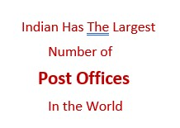

PROUD TO BE AN INDIAN

Interesting Facts About

ANIMAL WORLD

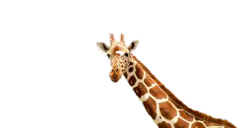

Giraffes Are The Tallest

Mammal

In The world.

Giraffes Have **Huge** Hearts.

Zebras Stripes Are

Unique Like

Fingerprints.

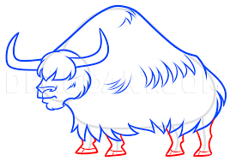In **Winter**

A Yak Can Survive

Temperatures As low As

**-40 Degrees C**

**Yaks Live At The Highest Altitude Of Any Mammal.**

**END**